
Licensed Real Estate Broker

Great Neighborhood
12 Birch Drive, Amenia, NY
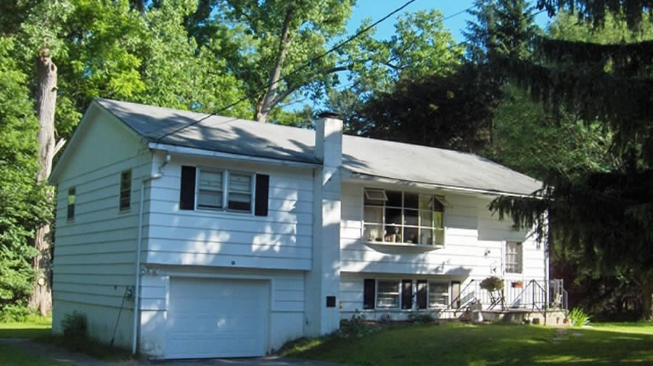
$269,000 Now $249,000 (under contract)

Style: Raised Ranch Bedrooms: 3/4 Bathrooms: 2

Stories: 2 Living Room: 17’ x 13’

Square Feet: 1,582 Kitchen: 17’ x 11’

Lot Size: .35 acres Bedroom: 14’ x 11’
Year Built: 1967 Bedroom: 11’ x 10’
Taxes: $2959 w/Star (2006) Bedroom: 11’ x 11’
Roof: Asphalt Shingle Bedroom: 11’ x 11’
Electric: 100 Amps, circuit breakers Family Room: 18’ x 12’
Heat: BBHW Mid-Hudson MLS: #249450
CCND MLS: #65135
The joys and benefits of living in a small town in a fabulous neighborhood may only be matched by the rewards and pride of home ownership. This very sweet home features well proportioned rooms, a living room and family room, 2 baths, sparkling hardwood floors. A level yard offers enough room for the family picnic or the neighborhood football game. Birch Drive is a quiet cul de sac and it is just a short walk to the Hamlet of Amenia. Dozens of activities are all very convenient. Metro North is about 12 miles away.

The real estate data for sale on this website is subject to errors, omissions, changes, and withdrawal without notice. Information deemed to be reliable but not guaranteed.
3298 Route 343 (East Main Street) PO Box 15 Amenia, New York 12501-0015
TEL: 845.373.8555 FAX: 845.373.9850 eMail: havensre@verizon.net
www.havensre.com

