
3300 Route 343 (East Main Street) PO Box 15 Amenia, New York 12501-0015
TEL: 845.373.8555 FAX: 845.373.9850 email: havensre@optonline.net
www.havensre.com

Licensed Real Estate Broker
Great House, Fabulous Area
117 Quarry Hill Road, Millerton, New York
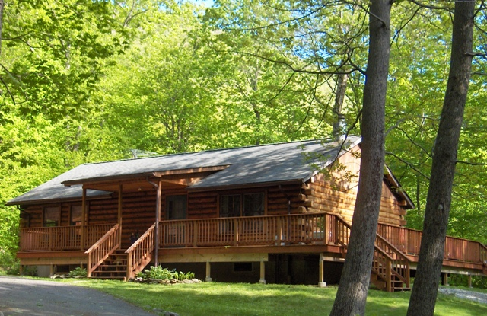
SOLD

Style: Log Home Bedrooms: 2 Bathrooms: 1

Stories: 1 Living Room: 21’ x 14’ w/FP

Square Feet: 1,050 Kitchen: 9’ x 9’
Lot Size: 2.5 acres Dining Area: 12’ x 9”
Year Built: 1986 Bedroom: 12’ x 12’
Taxes: $4,382(2010) Bedroom: 17’ x 8’
Heat: BB Electric Deck: 50’ x 17’6”
CCND MLS: #76889 Mid-Hudson MLS: #286733

The best of the country life: great house, fabulous area. Nestled at the base of the Taconics and just minutes to the Village of Millerton, State Parks, Golf, Skiing, Rail Trail, Metro North is 15 miles away. Home features include: sky lights, cathedral ceilings, fireplace, large deck with a hot tub, full basement and a 2 car detached garage. Not to be overlooked, this is an amazing quality of life.

The real estate data for sale on this website is subject to errors, omissions, changes, and withdrawal without notice. Information deemed to be reliable but not guaranteed.

