
Licensed Real Estate Broker

Peaceful Living
117 Bog Hollow Rd. Wassaic, NY
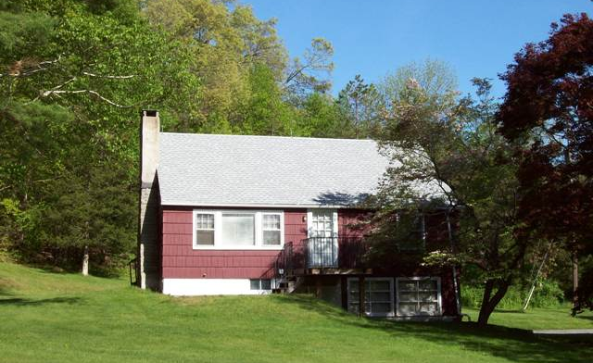
$189,000 Now: $169,000 (SOLD)

Style: Cape Bedrooms: 2 Bathrooms: 2

Levels: 2 w/walk up attic Living Room: 16’ x 13’

Square Feet: 1,109 Kitchen: 14’ x 12’

Lot Size: 1.4 acres Bedroom: 13’ x 13”
Year Built: 1960 Bedroom: 11’ x 9’
Taxes: $3,637 Family Room/Office (lower level) 13’ x 13’
Exterior: Shake Heat: BBHW
Roof: Asphalt Shingle (new) CCND MLS: #82959
Electric: 100 Amps, circuit breakers Mid-Hudson MLS: #303733

Oh what a setting! Conveniently located between Amenia – Sharon, CT – Kent, CT and just minutes from the Ten Mile River or Wassaic Train Stations. This glorious 1.4 acre property is filled with outdoor splendor and the home is so adorable. The roof and boiler are recent replacements. The hardwood floors are very attractive and the living room features beamed ceilings, a wood burning fireplace and charming genuine wood paneling. This is a perfect starter home and weekenders will thoroughly enjoy just how quaint this home is and the ease of access to the marvelous countryside and nearby attractions.

The real estate data for sale on this website is subject to errors, omissions, changes, and withdrawal without notice. Information deemed to be reliable but not guaranteed.
3300 Route 343 (East Main Street) PO Box 15 Amenia, New York 12501-0015
TEL: 845.373.8555 FAX: 845.373.9850 eMail: havensre@optonline.net
www.havensre.com

