
Licensed Real Estate Broker
3300 Route 343 (East Main Street) PO Box 15 Amenia, New York 12501-0015
TEL: 845.373.8555 FAX: 845.373.9850 email: havensre@optonline.net
www.havensre.com

And a Pond Too
111 Perry Corners Road, Town of Amenia
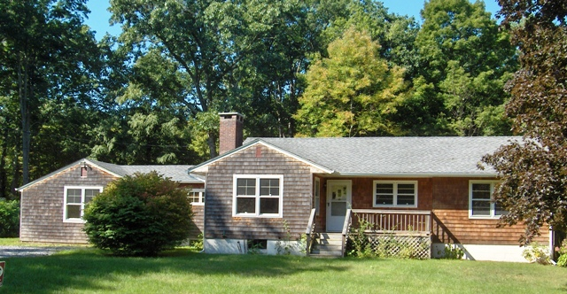$SOLD

Style: Ranch Bedrooms: 3 Bathrooms: 2

Stories: 1 Living Room: 20’ x 13’ w FP

Square Feet: 1900 Kitchen: 13’ x 10’

Lot Size: 3.8 acres Dining Room: 11’ x 11’
Year Built: 1958 Bedroom: 15’ x 11’
Taxes: $5,203 (2010) Bedroom: 15’ x 11’
Exterior: Cedar Shake Bedroom: 10’ x 9’
Roof: Asphalt Shingle Family Room: 23’ x 18’
Electric: 100 Amps, circuit breakers CCND MLS: #77848
Heat: BBHW oil new boiler Mid-Hudson MLS: #289340

Clean as a whistle, freshly painted and hard wood floors polished this home is impeccable. These owners have replaced the roof, replaced the windows, installed the cedar shake siding and the boiler is brand new. A most attractive country setting located just minutes from the center of Amenia, Metro North, State Parks, Golf, Skiing and the Harlem Valley Rail Trail. There are several private schools that are also nearby. This level parcel includes a spring fed pond, lawn and garden areas and some woodland. The Living room with a stone fireplace is filled with charm and very inviting and the 23x18 family room would make the perfect studio, library, home office as an all purpose room for the entire family.

The real estate data for sale on this website is subject to errors, omissions, changes, and withdrawal without notice. Information deemed to be reliable but not guaranteed.

