
3298 Route 343 (East Main Street) PO Box 15 Amenia, New York 12501-0015
TEL: 845.373.8555 FAX: 845.373.9850 eMail: havensre@verizon.net
www.havensre.com

Licensed Real Estate Broker

110 Cascade Mountain Road, Amenia, New York 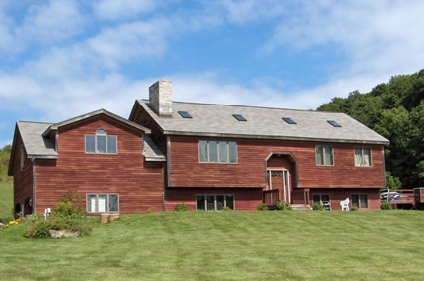
$449,000 (SOLD)

Style: Contemporary Living Room: 27’ x 23’

Stories: 2 Kitchen: 15’ x 12

Square Feet: 2,756 Dining Area: 12’ x 12’
Lot Size: 3.99 acres Master Bedroom: 26’ x 15’

Year Built: 1992 Master Bathroom: 12’ x 9’
Taxes: $4,671 (2005) Bedroom: 13’ x 11’

Exterior: Clapboard Bedroom: 13’ x 10’
Roof: Asphalt Shingle Bedroom: 11’ x 11’
Heat: Oil, Baseboard, zoned Bathroom: 8’ x 7’

Fireplaces: 1 in Family Room Mid-Hudson MLS: #226344

Bathrooms: 2.5 CCND MLS: #58010

Rambling rustic contemporary on 3.99 acres. High ceilings with wood accents. Spacious sun filled rooms. Cozy family room with fireplace, 27 x 23 living room. 26 x 15 Master Bedroom. A private setting with spectacular big sky and rolling countryside views. Taxes shown reflect star exemption. Located just 3 miles from Metro North.

The real estate data for sale on this website is subject to errors, omissions, changes, and withdrawal without notice. Information deemed to be reliable but not guaranteed.

