
3298 Route 343 (East Main Street) PO Box 15 Amenia, New York 12501-0015
TEL: 845.373.8555 FAX: 845.373.9850 eMail: havensre@verizon.net
www.havensre.com

Licensed Real Estate Broker

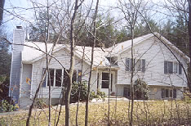 | Briarwood Lane  10 Briarwood Lane  Millerton, New York  Offered for the first time. This remarkable 3 bedroom, 2 bath home was built in 1992. The home is in a very quiet area of the Town of Northeast on a 1.8 acre corner parcel that is lightly wooded acres.  Price: SOLD  School tax: $2898.00  Town tax: $1410.00  School: Webutuck
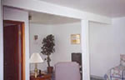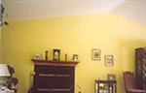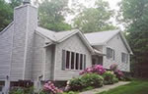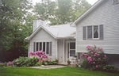

Style: | Ranch | Bedrooms: | 3
Stories: | Two | Living Room:
Square Feet: | 1,882 | Dining Room:
Lot Size: | 1.8 acres | Kitchen:
Year Built: | 1992 | Master Bedroom:
Floors: | Ceramic, Carpet (Bedrooms) | Bedroom #1:
Basement: | Finished (Family), Walkout | Bedroom #2:
Garage: | Full 2 car under with walkout | Den/Bedroom #3:
Heat: |  | Baths: | 2

Additional:
The home features ceramic tile floors in the living room with vaulted ceiling and an inviting fireplace. The eat-in kitchen, dining room and family room all have ceramic tile floors as well. Home also has a spacious and private deck and a 2-car garage with a workplace.Appliances included: Clothes Dryer, Dishwasher, Refrigerator, Range, Clothes Washer. $200 per year for the Home Owner’s Association.

