
Licensed Real Estate Broker
3300 Route 343 (East Main Street) PO Box 15 Amenia, New York 12501-0015
TEL: 845.373.8555 FAX: 845.373.9850 eMail: havensre@optonline.net
www.havensre.com

10 Briarwood Lane, Town of North East
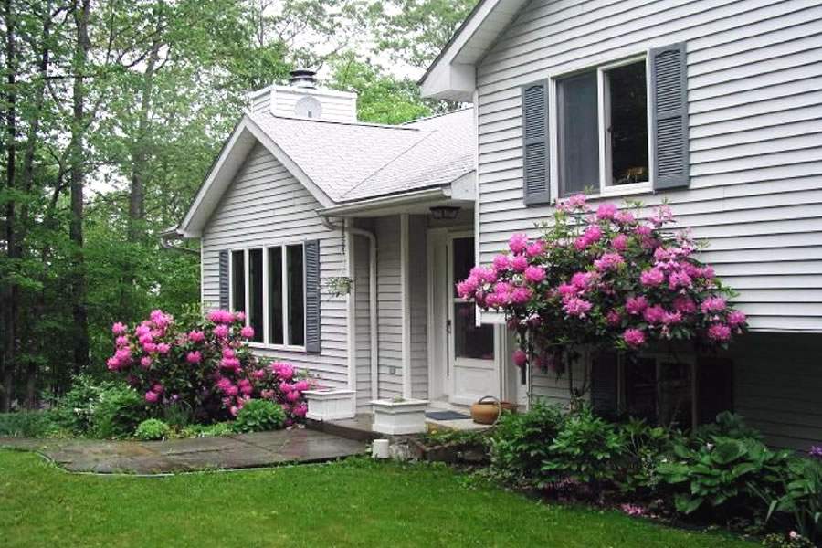
$389,000 $369,000 (SOLD)

Style: Split Level Bedrooms: 3 Bathrooms: 2

Stories: 2 Living Room: 19’ x 13’ w/FP

Square Feet: 1882 Kitchen: 13’ x 11’

Lot Size: 1.8 acres Dining Area: 12’ x 12’
Year Built: 1992 Master Bedroom: 13’ x 11’
Taxes: $4,669 Bedroom: 13’ x 11’
Exterior: Vinyl Bedroom: 10’ x 9’
Roof: Asphalt Shingle Family Room: 19’ x 14’
Electric: 200 Amps, circuit breakers Mid-Hudson MLS: 262460
Heat: BBHW CCND MLS: #69018
A great location only minutes from the Village of Millerton and the Wassaic Train Station. Skiing, hiking, biking and golfing are all nearby. Privately nestled in a lightly wooded parcel with ample sunlight for sensational plantings, this immaculate 3 bedroom, 2 bath has been pride fully maintained inside and out. The main living areas feature ceramic tile floors that are extremely durable and a snap to care for. In addition to the light filled living room with a fireplace there is a lower level family room that offers unique space for a variety of purposes.

The real estate data for sale on this website is subject to errors, omissions, changes, and withdrawal without notice. Information deemed to be reliable but not guaranteed.

