105 Old Post Road # 4, Millerton, NY

Licensed Real Estate Broker
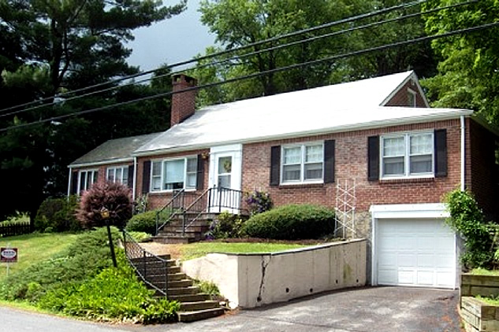
$259,000 (SOLD)

Style: Cape Bedrooms: 2

Stories: 1.5 Bathroom: 1 Full

Square Feet: 1,340 Living Room: 15’ x 13’ w/FP
Lot Size: .34 Dining Room: 11’ x 11’
Year Built: 1948 Kitchen: 14’ x 9’
Taxes: $2,110.00 (2005) Star Sr. Family Room: 15’ x 15’ w/ woodstove
Exterior: Brick Master Bedroom: 19’ x 11’
Driveway: Blacktop Bedroom 2: 11’ x 11’
Heat: BBHW Oil

The Little Brick House in the country is very very charming. An ideal country retreat with the Rail Trail, State Parks, Village of Millerton, golf, hiking and skiing all so convenient. This brick solid home was built in 1948 by the same family that has owned and occupied it since. The gardens are spectacular, the shade trees are beautiful, and the location is incredible. Features include hardwood floors through out, living room with fireplace and family room with a woodstove. Two rooms on the second level are unheated but with a little effort the possibilities are endless.
3298 Route 343 (East Main Street) PO Box 15 Amenia, New York 12501-0015
TEL: 845.373.8555 FAX: 845.373.9850 eMail: havensre@verizon.net
www.havensre.com

The real estate data for sale on this website is subject to errors, omissions, changes, and withdrawal without notice. Information deemed to be reliable but not guaranteed.

