
Licensed Real Estate Broker
3298 Route 343 (East Main Street) PO Box 15 Amenia, New York 12501-0015
TEL: 845.373.8555 FAX: 845.373.9850 email: havensre@optonline.net
www.havensre.com

Cottage Cove
102 Douglas Road, Sharon, CT
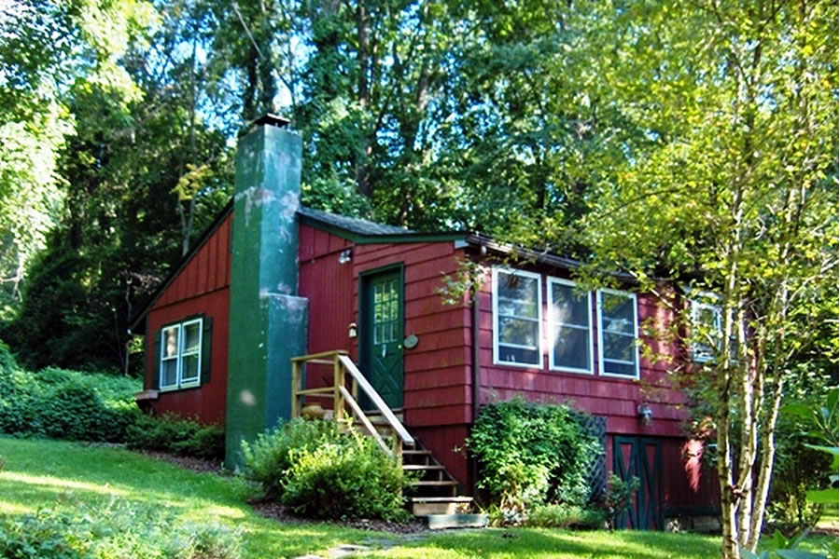
$195,000 - SOLD

Style: Cottage Bedrooms: 1

Stories: 1 Bathrooms: 1

Square Feet: 644 Living Room: 14’ x 13’ w/FP

Lot Size: .18 acre Kitchen: 16’ x 10’
Year Built: 1954, updated in ’03 Master Bedroom: 23’ x 9’
Taxes: $1,165 Deck: 22’ x 17’
Exterior: Shakes, Wood
Roof: Shingle
Electric: 200 Amps Mid-Hudson MLS: #270010
Heat: Forced Hot Air CCND MLS: #71396

Cute as can be, yet rugged, as it needs to be. But for sure it well appointed and the updates are plentiful. Cove Cottage is in move in condition; with it fully furnished, ownership has been made simple. Each generously proportioned room is filled with country charm. The setting is fairly private, the outside space is beautifully planted and the deck is very inviting and there is deeded access to Mudge Pond. Located just minutes to nearby New England Villages and the Wassaic Train Station.
The real estate data for sale on this website is subject to errors, omissions, changes, and withdrawal without notice. Information deemed to be reliable but not guaranteed.

