
Licensed Real Estate Broker
3300 Route 343 (East Main Street) PO Box 15 Amenia, New York 12501-0015
TEL: 845.373.8555 FAX: 845.373.9850 eMail: havensre@optonline.net
www.havensre.com

Nature Calls
Quarry Hill Road
Town of North East, New York
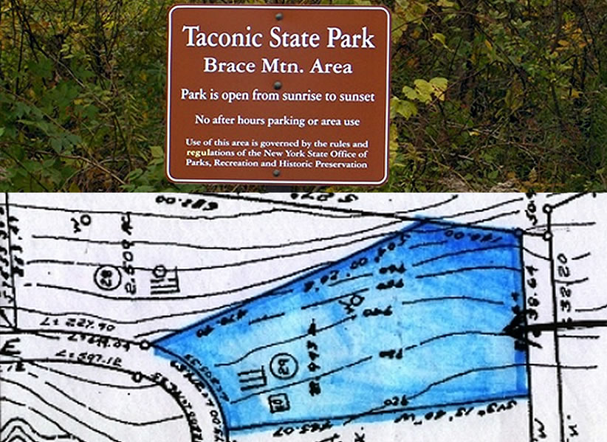
$159,000 Now: $149,000

Lot Size: 2.9 acres Taxes: $ 880. 2009-2010

Land parcel borders State Land and is very private. The potential for a property like this is limited only to your imagination. The old ore bed across the street stays filled with fresh water. The Brace Mountain hiking trail is just down the road and the wilderness is your neighbor. Private building site is perfect for the outdoorsman and extremely convenient to State Parks and Golf. Metro North (about 15 miles) makes the trip from NYC to the country well worth it.
Updated Board of Health Approval.

The real estate data for sale on this website is subject to errors, omissions, changes, and withdrawal without notice. Information deemed to be reliable but not guaranteed.

