
Licensed Real Estate Broker
3300 Route 343 (East Main Street) PO Box 15 Amenia, New York 12501-0015
TEL: 845.373.8555 FAX: 845.373.9850 email: havensre@optonline.net
www.havensre.com

Build a Home, Lovely Country Setting

Gun Club Road, Millerton, NY

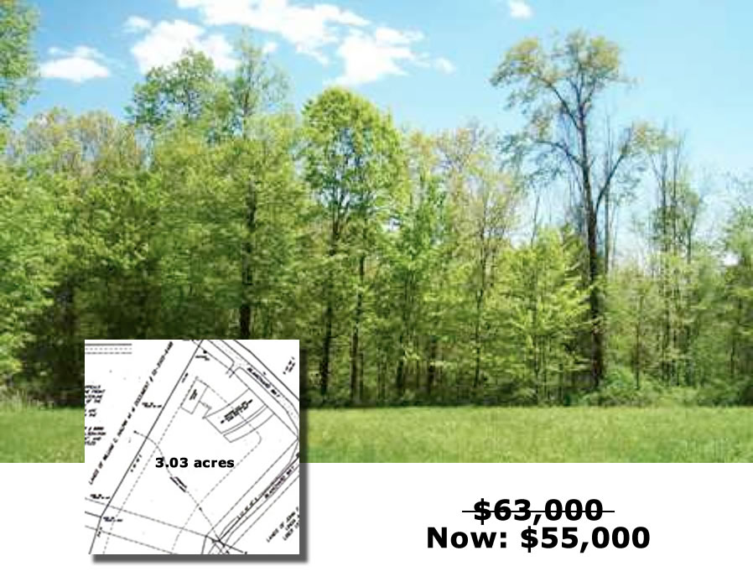

Located on a lightly traveled private road this parcel is just the right size and the price is right too! This home site is Board of Health Approved and there is electric on the street. With all the conveniences that Millerton and the surrounding area has to offer this may be the best building lot available today. Located just South of Millerton, minutes to the Wassaic Train Station and not a development setting. This will be a very nice place to call home.

The real estate data for sale on this website is subject to errors, omissions, changes, ad withdrawal without notice. Information deemed to be reliable but not guaranteed.

