
Licensed Real Estate Broker
3300 Route 343 (East Main Street) PO Box 15 Amenia, New York 12501-0015
TEL: 845.373.8555 FAX: 845.373.9850 email: havensre@optonline.net
www.havensre.com

Miles and Miles of View
Deer Run Road, Millerton, NY

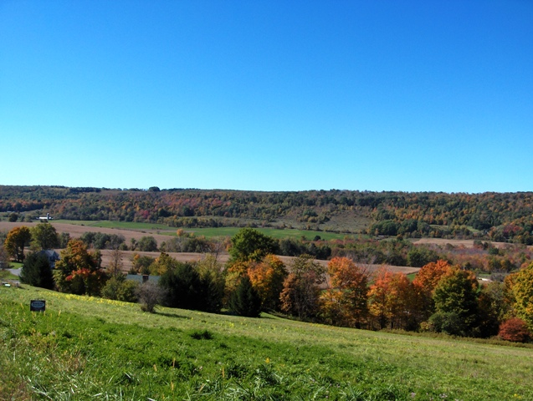
$250,000
BIG PRICE REDUCTION to $189,000

An outstanding home site consisting of 3.7 acres with extraordinary views of the magnificent countryside, dramatic blue skies, and spectacular sun rises and sun sets. Located in Rudd Pond Estates this parcel is in an area of fine homes just minutes to the Village of Millerton and an easy drive to the Wassaic Train Station. BOHA is current and a new well has been installed. 220 feet 13 gallons per minute.

The real estate data for sale on this website is subject to errors, omissions, changes, ad withdrawal without notice. Information deemed to be reliable but not guaranteed.

