Pristine Cottage Retreat
29 Finkle Rd, Pine Plains Plains, New York
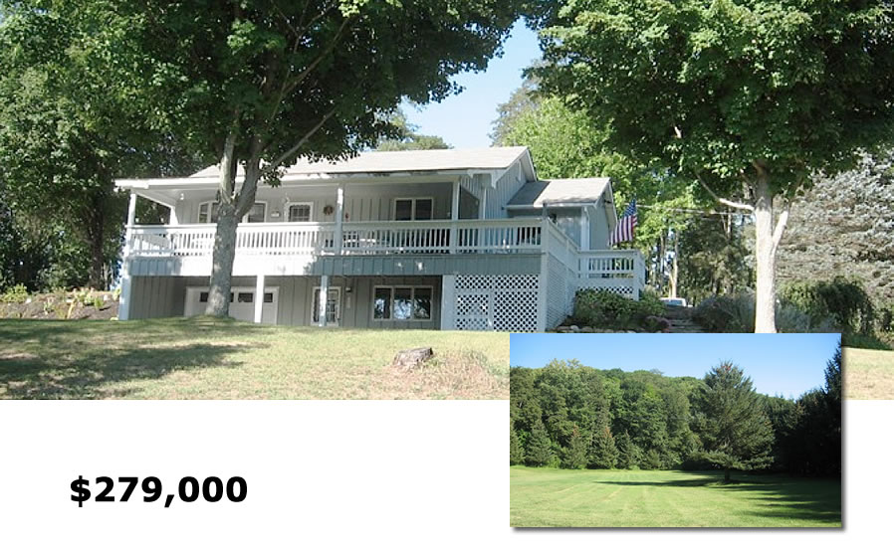

Licensed Real Estate Broker

Style: Private Country Cottage Bedrooms: 1 plus a guest area

Stories: 2 w/ finished family room Bathrooms: 2

Square Feet: 1522 Living Room: 14’ x 13’
Lot Size: 3.00 acres Kitchen / Dining Area: 17’ x 13’
Year Built: 1989 Bedroom: 16’ x 12’
Taxes: $3,704
Exterior: Wood Family room: 24’ x 12”
Roof: Asphalt Shingle CCND MLS: 105333
Heat: Electric Mid Hudson MLS: 343916

A captivating setting with mature trees, an open meadow (ideal for gardening) and framed by stately evergreens insuring privacy. Located about 3.5 miles from the Village of Millerton and just minutes to State Parks, Golf, Skiing, Rail Trail. Metro North is 12 miles away. The main level offers a bedroom, a full bath, and Great Room that consists of a well appointed Kitchen, Dining Area and Living Room. The lower level features a huge family room complimented with a gas stove and natural local wood presenting a touch of rustic and full bath. There are 2 garages and 3.00 park like acres featuring fabulous privacy. This perfect retreat is well put together and is in pristine condition!

The real estate data for sale on this website is subject to errors, omissions, changes, and withdrawal without notice. Information deemed to be reliable but not guaranteed.
3300 Route 343 (East Main Street) PO Box 15 Amenia, New York 12501-0015
TEL: 845.373.8555 FAX: 845.373.9850 eMail: havensre@optonline.net
www.havensre.com

