
3300 Route 343 (East Main Street) PO Box 15 Amenia, New York 12501-0015
TEL: 845.373.8555 FAX: 845.373.9850 email: havensre@optonline.net
www.havensre.com

Licensed Real Estate Broker

102 Quarry Hill Road, Millerton, New York
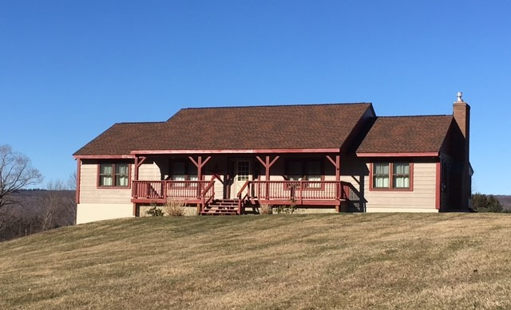
$359,000

Style: Log Home Bedrooms: 3

Stories: 1 Bathrooms: 2

Square Feet: 1844 Living Room: 25’ x 13’ w/FP
Lot Size: 2.8 acres Kitchen: 16’ x 13’
Year Built: 1987 Dining Room: 14’ x 11’
Taxes: $6,060 (2017) Master Bedroom: 24’ x 13’
Exterior: Log Bedroom 2: 12’ x 11’
Roof: Architectural Shingle Bedroom 3: 13’ x 10’
Heat: BBHW Oil Sun Porch: 14’ x 13’
Mid-Hudson MLS: #358954 CCND MLS: #113715

The best of the country life: great house, fabulous area, outstanding vistas. Nestled at the base of the Taconic’s and just minutes to the Village of Millerton, State Parks, Golf, Skiing, Rail Trail, Metro North is 18 miles away. This exquisite log home is solidly constructed and painstakingly maintained. Impressive features include a recently upgraded blacktop driveway, handsome glistening wide board floors, stone counter tops, a most appealing fireplace, a rocking chair front porch and a very private back deck. (both with fabulous views) and a screened sun porch. Not to be overlooked, this is an amazing quality of life.

The real estate data for sale on this website is subject to errors, omissions, changes, and withdrawal without notice. Information deemed to be reliable but not guaranteed.

